Multi Media Project description

Created by:

1. Nourhan Waheed
2. Nourhan Shehata
3. Galena Wagdy

We starting our windows application with welcoming page to the user , in the picture below

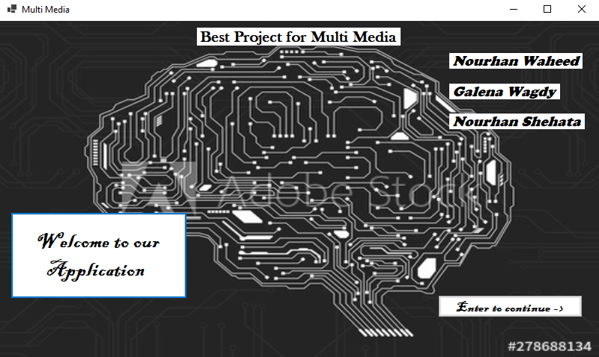

Press in the “Enter to continue “ button to get the next page that in the picture below :

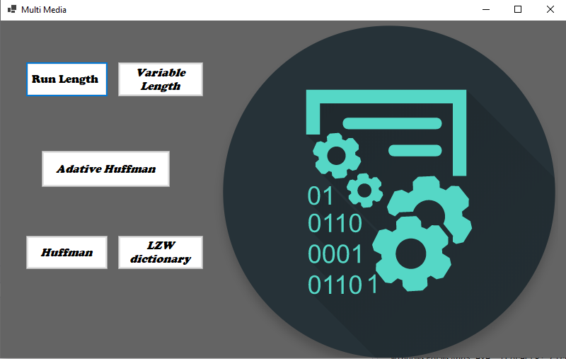

Press any button to each algorithm , I will start with run length algorithm in the picture below

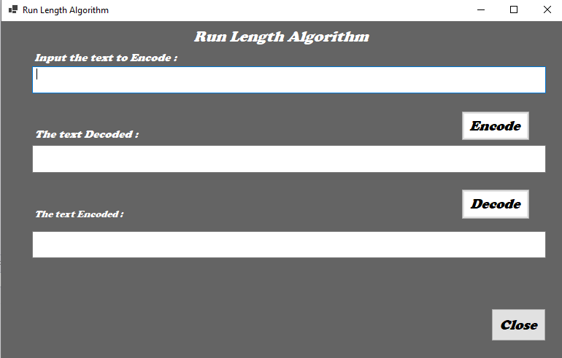

Input the text to be encoded and then press the “encode” button

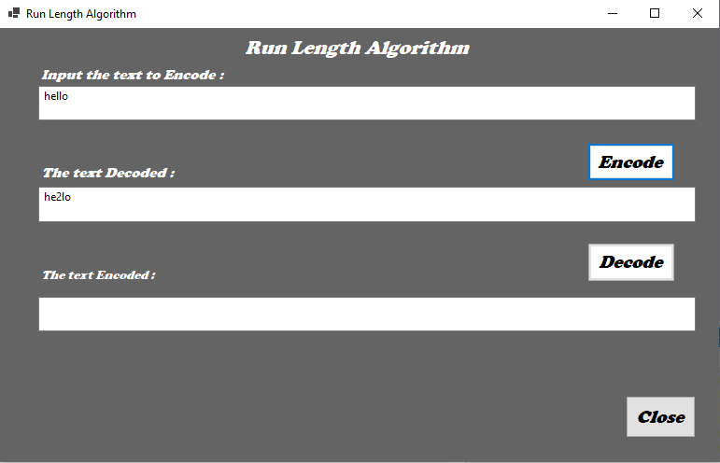

And then press decode to get the decode string

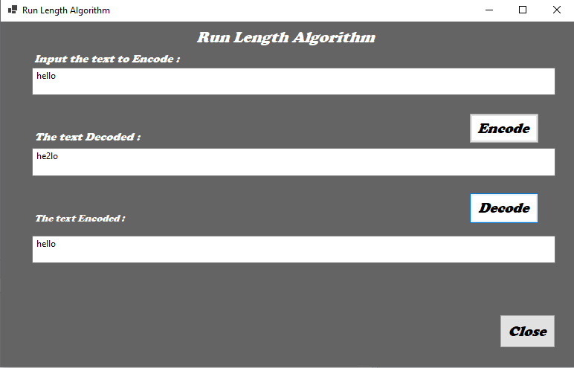

Press close to return to the algorithms page and then choose another algorithm , I choose variable length algorithm 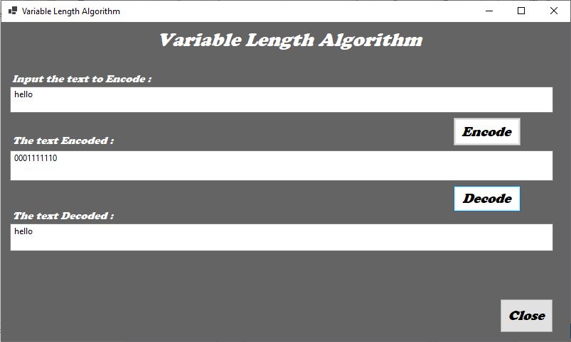

I entered the word “Hello” to be encoded and then get the decode form of the coding .

The picture above describe the steps and then press close to get another algorithm , I choose Adaptive Huffman Algorithm .

In this algorithm I used the word “hello” again to get the encode and decode form , but in the encode I preferred to output the char at every first input to make sure that the algorithm has a correct steps .

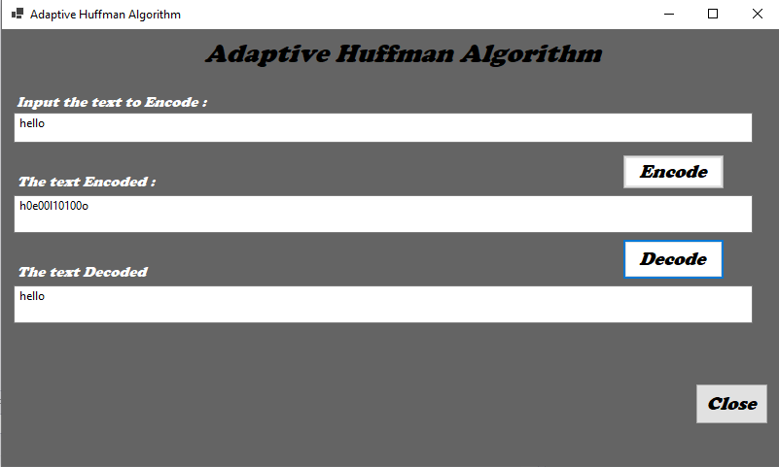

Then I pressed close and get the next algorithm “Huffman Algorithm”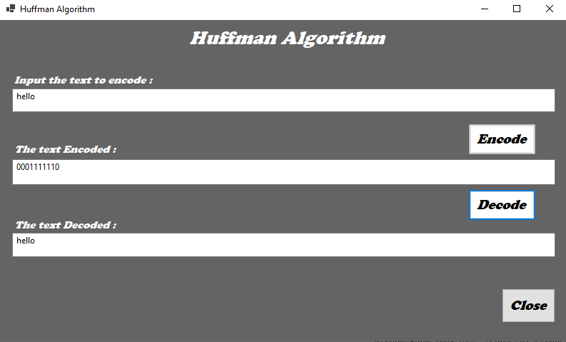

The same steps is done to get the results with this algorithm ang get the next

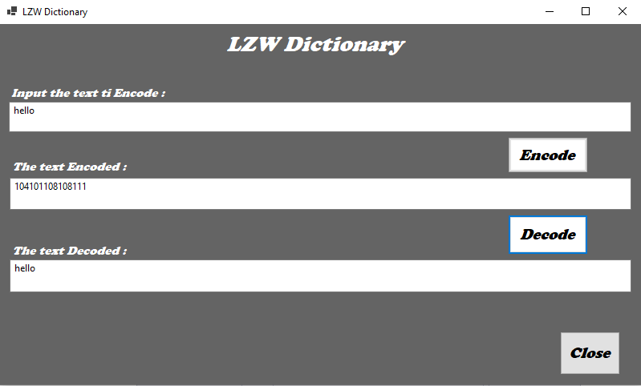

And finally the last algorithm “LZW Dictionary “ with the word “hello”.